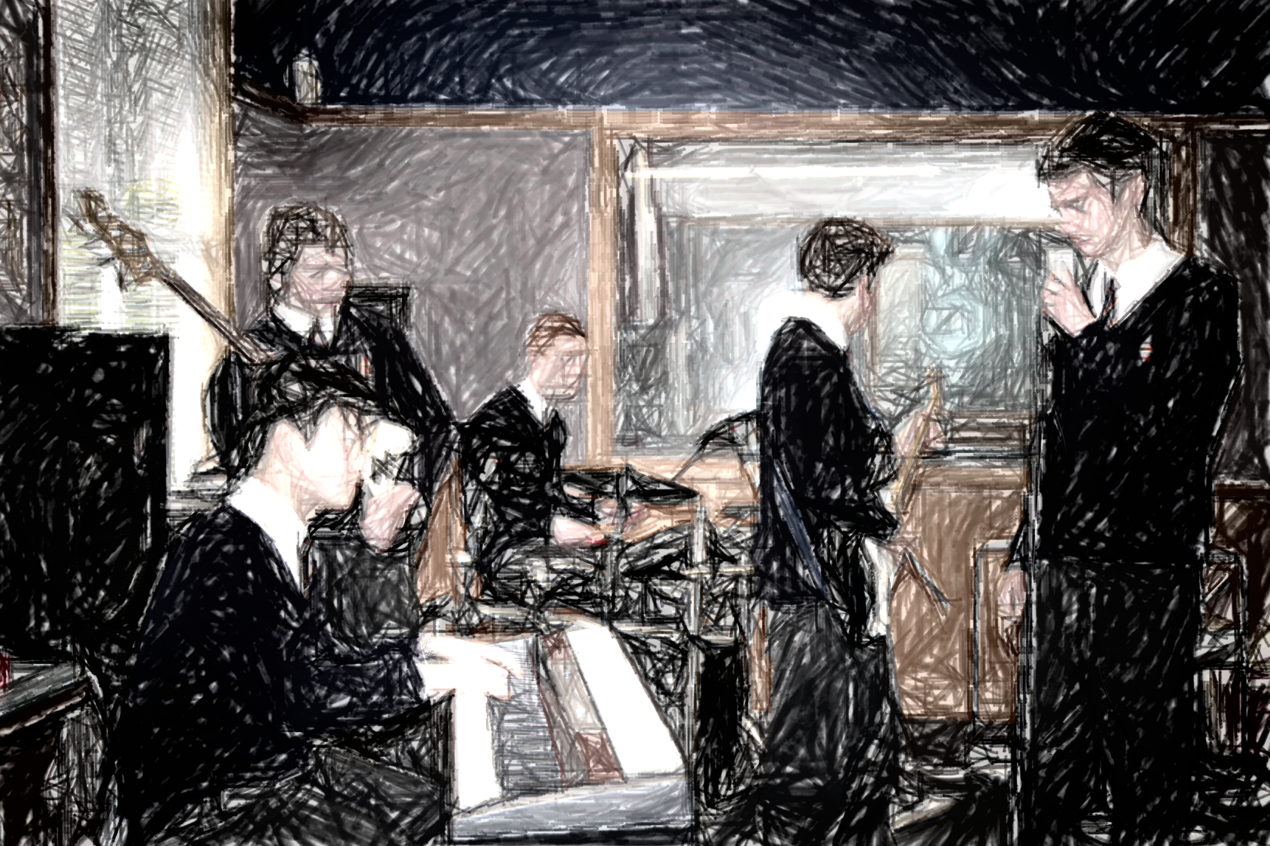

Level 1 Music will build upon the foundations laid in Year 10 Music in the following ways:

You will analyze music from a range of sound environments, styles, and genres, in relation to cultural, social, and historical contexts. (Understanding Music in Context)

You will consider and reflect on the influence of music in your own music making and in your life.

(Understanding Music in Context)

You will apply knowledge of the expressive features, stylistic conventions, and technologies through an integration of aural perception and practical and theoretical skills and describe how they are used in a range of music. (Developing Practical Knowledge)

You will create, structure, refine, and represent compositions using the elements of music, instruments, technologies and conventions to express imaginative thinking and personal understandings. (Developing Ideas)

You will reflect on composition processes and presentation conventions. (Developing Ideas)

You will prepare, rehearse, interpret and present performances of music, individually and collaboratively, using a range of performance skills and techniques. (Communicating and Interpreting)

You will reflect on the expressive qualities of music and evaluate your own and others’ music, both live and recorded. (Communicating and Interpreting)

# Welcome to the Music Department.

Level One Twenty Thirteen

MUSIC

John McGlashan College

##### Integer

Plato

Evidence for assessment of 91090 and 91091 will be recorded on camera. These recordings will be available for students to view so that reflection and evaluation can take place.

Work for NCEA internally assessed achievement standards not submitted on time, or not covered by an extension, will not be assessed. Extensions to the due date may be granted in special circumstances.

Samples of work from each standard will be independently moderated to ascertain if the work is at the national standard. Performance standards will be assessed by at least two qualified markers.

Students will be required to sign written work that is submitted to attest that it is their own, completed without help from others, and that you accept the mark that has been awarded. If you consider that your work has been unfairly assessed you may lodge an appeal within 2 school days of receiving the assessment.

You can access the standards, previous exam papers, examiners’ reports etc. at **http//wwww.nzqa.govt.nz/**

It would be sensible to make use of this facility.

Should be a great year. Hope you are looking forward to it.

Bruce James

HOD Music

|  |  |  |  |  |
| --- | --- | --- | --- | --- |
| **Standard** | **Name of standard** | **Credits** | **Assessment date (approx)** | **Re-assessment opportunity** |
| **91090 v1** | Perform two pieces of music as a featured soloist. | 6 | Term 2, week 4 Term 3, week 10 | No |
| **91091 v1** | Demonstrate ensemble skills through performing a piece of music as a member of a group. | 4 | Mid June & Term 2, week 10 | No |
| **91092 v1** | Compose two original pieces of music. | 6 | Term 1, week 10 Term 3, week 3 Term 4, week 1 | No |
| **91093 v1** | Demonstrate aural and theoretical skills through transcription. | 4 | External exam |  |
| **91094 v1** | Demonstrate knowledge of conventions used in music scores | 4 | External exam |  |
| **91095 v1** | Demonstrate knowledge of two music works from contrasting contexts | 6 | Term 1, Term 3 | No |

Please take careful note of when each task is to be assessed. Please see me immediately if you have any problems with any aspect of the course.

Because performance is a large part of this course, you will need to commit to attending regular tuition in your instrument. Please make sure that I have full details of who you are receiving tuition from. Daily practice on your instrument is also recommended. Instrumental tuition fees and instrument hire fees are the responsibility of the student.

Senior music students are also expected to participate in at least one ensemble which may include the school choir, jazz band or another ensemble group.

This year, the Year 11 Music course contributes up to 24 credits toward your Level 1 NCEA qualification.

Your progress and learning will be assessed against the standards shown in the table below. Standards are either assessed at school in the course of the year, **(internal standards)**, or are assessed by examination at the end of the year, **(external standards)**. You will need to obtain a minimum of 15 credits to be eligible to continue with Year 12 (Level 2) Music.

Two standards at Level 1 – 91093 and 91094 – are examined by external exam at the conclusion of the school year. They will also be assessed during internal exams in Term 3 to monitor your progress, and to provide evidence for a derived grade should this prove necessary. The remainder are internally assessed.

# Below are the standards that make up your course of study for this year.

Page Two

##### Etiam et urna

#### .Etiam