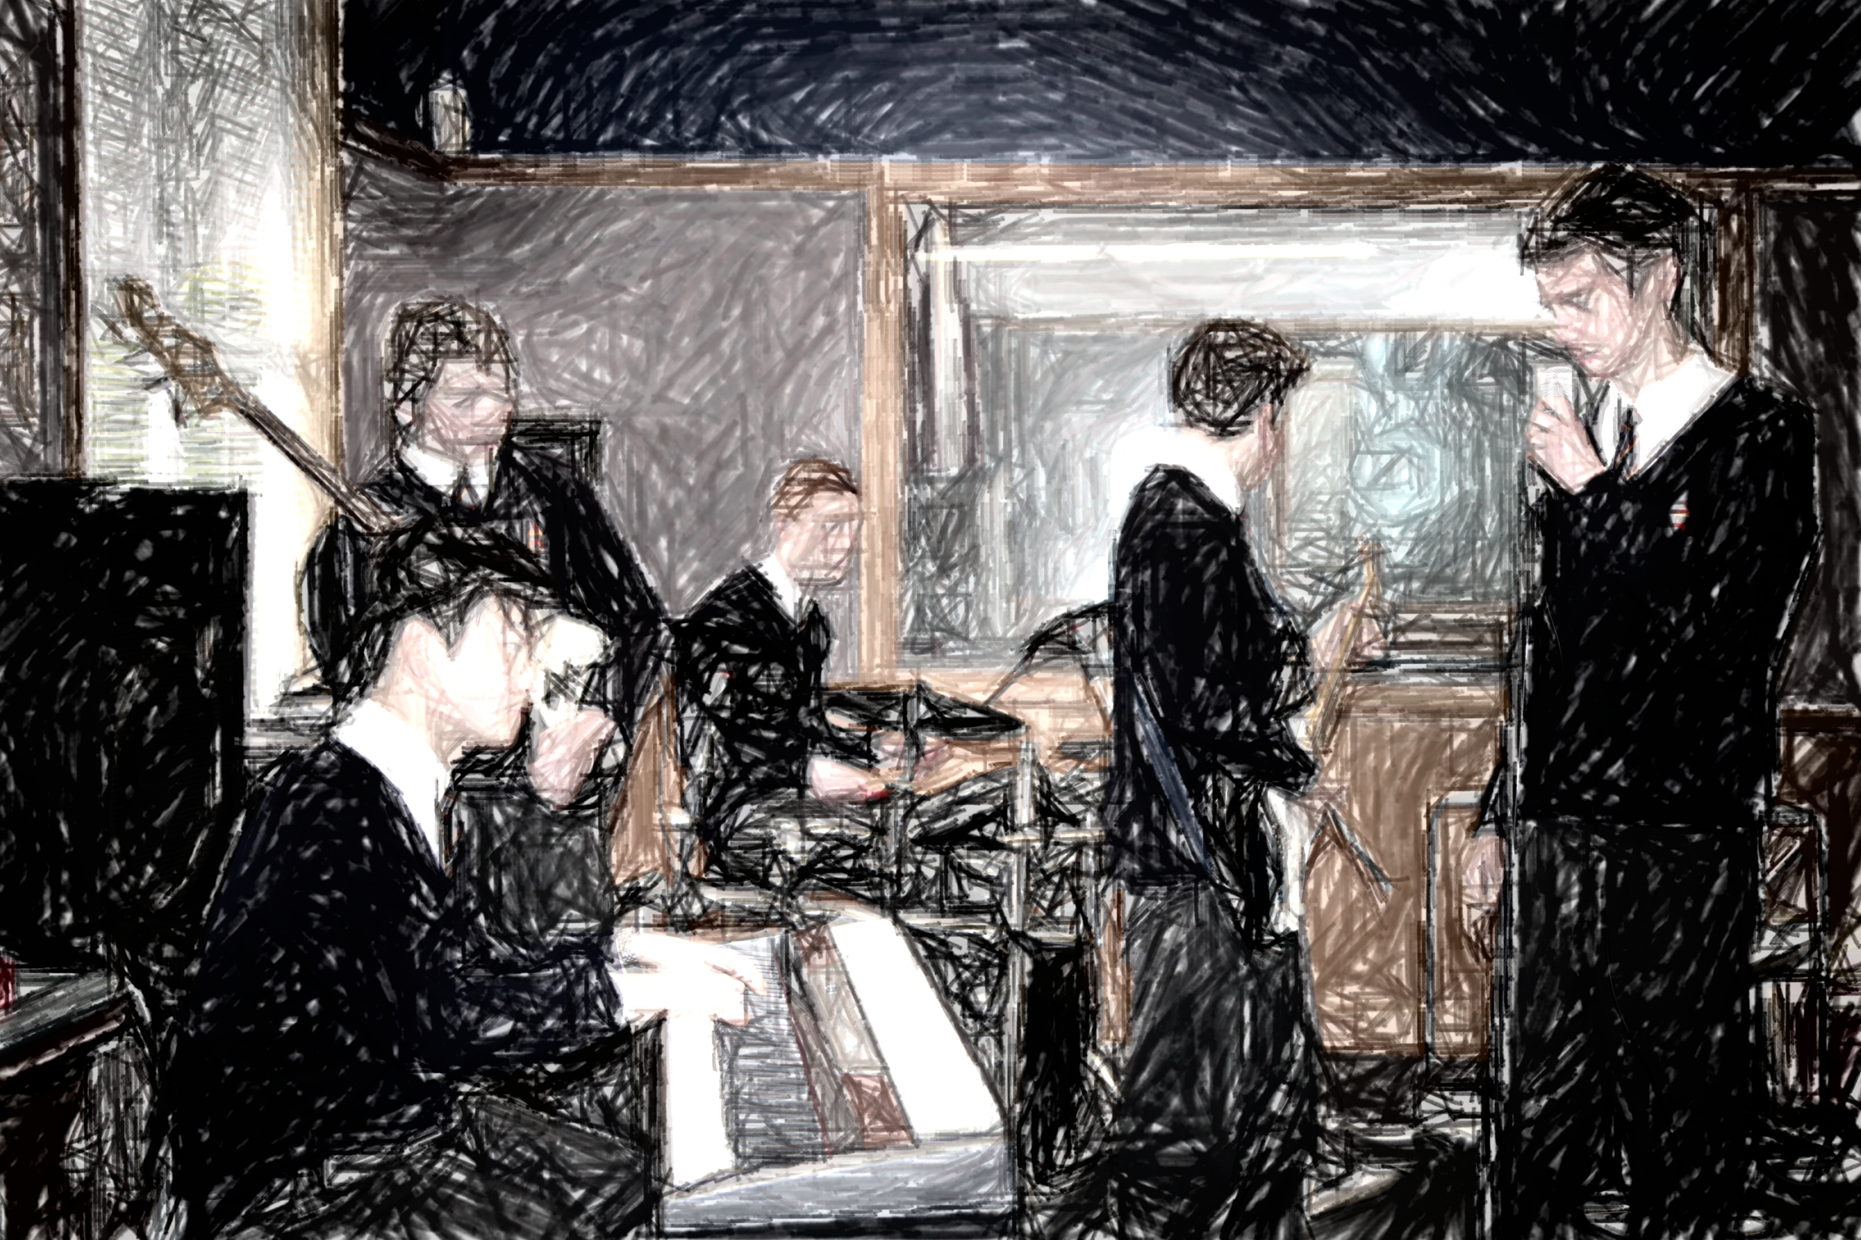

Level 2 Music will build upon the foundations laid in Level 1 in the following ways:

You will research and analyze music from a range of sound environments, styles, and genres, in relation to cultural, social, and historical contexts, considering the impact on music making and production. (Understanding Music in Context)

You will apply your understandings of the expressive qualities of music from a range of contexts to a consideration of the influence on your own music practices. (Understanding Music in Context)

You will apply knowledge of the expressive features, stylistic conventions, and technologies through an integration of aural perception and practical and theoretical skills and analyze how they are used in a range of music. (Developing Practical Knowledge)

You will create, structure, refine, and represent compositions and musical arrangements, using technical and musical skills and technologies to express imaginative thinking and personal understandings. (Developing Ideas)

You will reflect on and evaluate composition processes and presentation conventions. (Developing Ideas)

You will prepare, rehearse, present, record, and evaluate sustained performances of music, individually and collaboratively, that demonstrate interpretive understandings. (Communicating and Interpreting)

You will analyze and evaluate the expressive qualities of music and production processes to inform interpretations of music. (Communicating and Interpreting)

You will be choosing an individual course in consultation with me up to a maximum of 24 credits. Standards are either assessed at school during the course of the year, (internal standards), or are assessed by examination at the end of the year, (external standards). You will need to obtain a minimum of 15 credits to be eligible to continue with Year 13 (Level 3) Music.

Three standards at level 2, (91275, 91276 and 91277), are examined by external exam at the conclusion of the school year. Obtaining a merit or excellence in at least one of these will enable you to be considered for an endorsed subject certificate. They will also be assessed during internal exams in Term 3 to monitor your progress. The remainder are internally assessed. Please take careful note of when each task is to be assessed. Please see me immediately if you have any problems with any aspect of the course.

Level Two Twenty Thirteen

# Welcome to the Music Department.

MUSIC

John McGlashan College

##### Integer

Plato

Evidence for assessment of 91270, 91274, and 91272 will be recorded on camera. These recordings will be available for students to view so that reflection and evaluation can take place. Work for NCEA internally assessed achievement standards not submitted on time, or not covered by an extension, will not be assessed. Extensions to the due date may be granted in special circumstances.

Samples of work from each standard will be independently moderated to ascertain if the work is at the national standard. Performance standards will be assessed by at least two qualified markers.

Students will be required to sign written work that is submitted to attest that it is their own, completed without help from others, and that you accept the mark that has been awarded. If you consider that your work has been unfairly assessed you may lodge an appeal within 2 school days of receiving the assessment.

You can access the standards, previous exam papers, examiners’ reports etc. at **http//wwww.nzqa.govt.nz/**

It would be sensible to make use of this facility.

Should be a great year. Hope you are looking forward to it.

Bruce James

HOD Music

|  |  |  |  |  |
| --- | --- | --- | --- | --- |
| **Standard No.** | **Standard Name** | **Credit value** | **Indicative assessment times** | **Re-assessment opportunity?** |
| 91270 v1 | Perform two substantial pieces of music as a featured soloist | 6 | Term 2 week 4 & term 3 week 10 | No |
| 91274 v1 | Perform a substantial piece of music as a featured soloist on a second instrument | 3 | Term 2 week 4 or term 3 week 10 | Yes, if not achieved at first assessment opportunity |
| 91272 v1 | Demonstrate ensemble skills by performing a substantial piece of music as a member of a group | 4 | Term 2 week 10 | No |
| 91271 v1 | Compose two substantial pieces of music | 6 | Term 1, week 10, term 3 week 3 & term 4 week 1 | No |
| 91275 v1 | Demonstrate aural understanding through written representation | 4 | External exam |  |
| 91276 v1 | Demonstrate knowledge of conventions in a range of music scores | 4 | External exam |  |
| 91277 v1 | Demonstrate understanding of two substantial contrasting music works | 6 | External exam |  |
| 91273 v1 | Devise an instrumentation for an ensemble | 4 | Term 2 week 8 | 1 |
| 91278 v1 | Investigate an aspect of New Zealand music | 4 | Term 3 week 6 | 1 |
|  | **Please note that 10655 is an alternative to 91271. You need to choose one option only.** | | | |

Because performance is a large part of this course, you will need to commit to attending regular tuition in your instrument. Please make sure that I have full details of who you are receiving tuition from. Daily practice on your instrument is also expected. Instrumental tuition fees and instrument hire are the responsibility of the student.

Senior music students are also expected to participate in either the school choir, jazz band or an ensemble group.

# Below are the standards that make up your course of study for this year.

Page Two