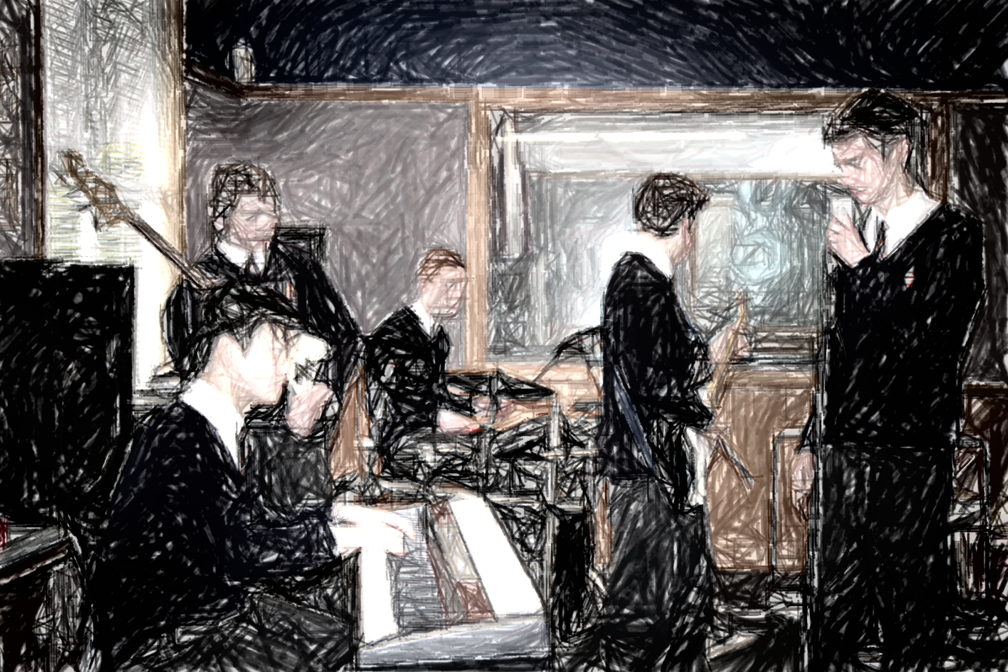

Level 3 Music will build upon the skills you have developed in Level 1 and Level 2 in the following ways:

You will research and analyze music from a range of sound environments, styles, and genres, in relation to cultural, social, and historical contexts, considering the impact on music making and production. (Understanding Music in Context)

You will apply your understandings of the expressive qualities of music from a range of contexts to a consideration of the influence on your own music practices. (Understanding Music in Context)

You will apply knowledge of the expressive features, stylistic conventions, and technologies through an integration of aural perception and practical and theoretical skills and analyze how they are used in a range of music. (Developing Practical Knowledge)

You will create, structure, refine, and represent compositions and musical arrangements, using technical and musical skills and technologies to express imaginative thinking and personal understandings. (Developing Ideas)

You will reflect on and evaluate composition processes and presentation conventions. (Developing Ideas)

You will prepare, rehearse, present, record, and evaluate sustained performances of music, individually and collaboratively, that demonstrate interpretive understandings. (Communicating and Interpreting)

You will analyze and evaluate the expressive qualities of music and production processes to inform interpretations of music. (Communicating and Interpreting)

Please take careful note of when each task is to be assessed. Please see the teacher immediately if you have any problems with any aspect of the course.

If solo performance is a component of your course, you will need to commit to attending regular tuition in your instrument. Please make sure that the teacher has full details of who you are receiving tuition from. Daily practice on your instrument will be essential, and the homework component of classroom activities will allow for this. Instrumental tuition fees and instrument hire are the responsibility of the student.

Senior music students are also expected to participate in either the school choir, jazz band or an ensemble group.

Each student has a personalised course selected from the Standards listed below. A student needs to choose a mix of standards that total between 19 and 25 credits. Take the time to highlight those that apply to you. In specific instances some students may take an individualised course with approval from the HOD. This may be because of limited success at level 2 or because of prior achievement at level 3.

Level Three Twenty Thirteen

# Welcome to the Music Department.

MUSIC

John McGlashan College

##### Integer

Plato

Evidence for assessment 3.1, 3.2 and 3.3 will be recorded on camera. These recordings will be available for

students to view so that reflection and evaluation can take place. Work for NCEA internally assessed achievement standards not submitted on time, or not covered by an extension, will not be assessed. Extensions to the due date may be granted in special circumstances.

Samples of work from each standard will be independently moderated to ascertain if the work is at the national standard. Performance standards will be assessed by at least two qualified markers.

Students will be required to sign written work that is submitted to attest that it is their own, completed without help from others, and that you accept the mark that has been awarded. If you consider that your work has been unfairly assessed you may lodge an appeal within 2 school days of receiving the assessment.

You can access the standards, previous exam papers, examiners’ reports etc. at **http//wwww.nzqa.govt.nz/**

It would be sensible to make use of this facility.

Should be a great year. Hope you are looking forward to it.

Bruce James

HOD Music

|  |  |  |  |  |
| --- | --- | --- | --- | --- |
| **Standard number** | **Name of standard** | **Credits** | **When it will be assessed (approximately)** | **Re-assessment opportunity** |
| 3.1 | Perform two programmes of music as a featured soloist | 8 | Term 2 week 4 and term 3 week 10 | No |
| 3.2 | Perform a programme of music as a featured soloist on a second instrument | 4 | Term 2 week 4 or term 3 week 10 | No |
| 3.3 | Demonstrate ensemble skills by performing two substantial pieces as a member of a group | 4 | Term 2 week 10 | No |
| 3.4 | Communicate musical intention by composing three original pieces of music | 8 | Term 1 week 10, term 2 week 9, term 3 week 4, and term 4 week 1 | No |
| 3.5 | Integrate aural skills into written representation | 4 | External examination |  |
| 3.6 | Demonstrate understanding of harmonic and tonal conventions in a range of music scores | 4 | External examination |  |
| 3.7 | Analyse a substantial work | 4 | External examination |  |
| 3.9 | Create two arrangements for an ensemble | 4 | Term 1 week 9, Term 2 week 5, and Term 3 week 2 | No |
| 3.10 | Research a music topic | 6 | Term 1 week 9, Term 2 week 2, Term 2 week 8, Term 3 week 3 and Term 4 week 1 | No |
| US 16553 | Make a significant contribution to a performing ensemble | 10 | Term 4, week 2 | No |

All students are encouraged to take 3.6, or an appropriate alternative. Obtaining a merit or excellence in this external standard will enable you to be considered for an endorsed subject certificate. Please note that 3.4 and 10656 are mutually exclusive. You may choose only one option. Please note that with most of these standards, as the work involves regular tutorials with the teacher and the portfolio of work is constructed over time, there will be no re-assessment opportunities.

# Below are the standards that make up your course of study for this year.

Page Two